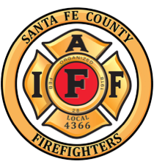

2026
Santa Fe County Professional Firefighters Association
Candidate Questionnaire

- Campaign Information

Candidate Name:

Position Sought:

Campaign Committee Name:

Address ____ __________________________ Zip code _________

Campaign Phone Number: Other Phone Number:

Email Address:

Social Media Pages:

Campaign Manager Name:

Campaign Manager Phone Number:

Campaign Information Cont.

- What Office do you currently hold?

- Have you ever received the endorsement of SFCPFFA or another IAFF affiliate?

Yes No

If the answer to the previous question was yes, please list the IAFF Local(s) or State Associations that have endorsed you:

- History -
  - Please indicate your background, education and previous offices held.

b) please indicate any unique connections to the IAFF.

- Priorities

- What will your priorities be if elected?

- What are the most significant issues facing Santa Fe County Professional Firefighters from the perspective of the desired office you seek?

- Please explain what Public Safety means to you, How the Fire Service fits into that, and what public safety issues you will focus on if elected?

- How do you plan to strengthen the NM workforce and what labor issues will you focus on if elected?

- What issues are you aware of that are challenging the SFCPFFA and how you would address these issues as an elected official?

